AWS EBS - Elastic Block Store

What is AWS EBS?

AWS EBS is also called AWS Elastic Block Store.

EBS is a service that provides storage volumes.

You can use provided storage volumes in [Amazon EC2 instances](https://www.w3schools.com/aws/aws_cloudessentials_ec2instancetypes.php).

EBS volumes are used for data that needs to persist.

It is important to backup the data with **AWS EBS snapshots**.

After creating an EBS volume, you can attach it to an AWS EC2 instance.

If the EC2 instance stops or is terminated, all the data on the attached EBS volume remains.

What are AWS EBS Snapshots?

EBS snapshot is an incremental data backup.

The first backup of a volume backups all the data.

Every next backup copies only a block of data that has changed since the last snapshot.

It saves on storage costs by not duplicating data.

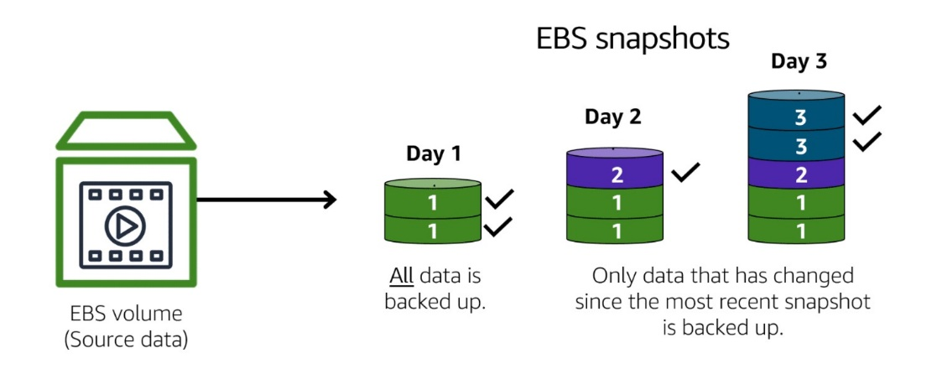

Image created by Amazon Web Services

The image illustrates how EBS Snapshots work.

Only the data unique to that snapshot is removed when you delete a snapshot.

If the EC2 instance stops, or is terminated, all the data on the attached EBS volume remains.